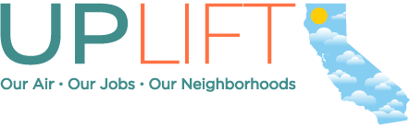

UPDATED SOCIAL MEDIA TOOLKIT – JULY/AUGUST 2015

ABOUT UPLIFT CALIFORNIA

Something amazing is happening in California: We’re charging polluters for the damage they cause and using that money to clean the air, save families money and bring investments and jobs to communities that need them.

But too few Californians know this is happening, or the good it’s doing for our neighborhoods. UpLiftCA will change that.

UpLiftCA is a comprehensive campaign launched by The Greenlining Institute to educate our communities about California’s climate and clean energy laws and how the fight against global warming helps consumers, generates jobs, and helps build healthy, thriving neighborhoods. While these messages apply to all of us, we’re especially focusing on the communities of color and low-income Californians who too often suffer first and worst from pollution, climate change, and a stagnant economy. These communities have been targeted by an aggressive disinformation campaign from Big Oil and its front groups, and we intend to make sure that they hear the truth.

At UpLiftCA.org you can find stories of real California families whose lives have been changed for the better by our state’s climate policies, information about how these laws work, and a comprehensive collection of resources for families and small business owners.

In addition to an English site, we also have a dedicated Spanish website, and have created an outreach toolkit in Spanish to further help spread the word. We’re excited to see this campaign grow as new supporters and advocates join the movement to uplift California every day.

WHAT YOU CAN DO TO HELP

1. Spread the word to your networks – we need all the help we can get to ensure Californians know about this important resource and information hub. Big Oil is using millions of dollars to taint the image of our state’s effective climate policies. However, we have grassroots power, and that’s where you come in. We’ve created pre-made social media posts for Facebook, Twitter, and Instagram, as well as email language you can copy and paste to your networks to help get the word out.

2. Join the online conversation, and continue to engage with us through the hashtag: #UpLiftCA.

HELP PROMOTE UPLIFT CALIFORNIA

In addition to spreading the word on mainstream and ethnic media outlets, we’re looking to leverage the power of our community’s voices on social media and email to raise awareness about UpLiftCA. By tapping into the power of digital media, we want everyone to be directed to the website, and engage in meaningful relationship building and dialogue through our campaign hashtag.

Website: www.upliftca.org
Hashtag: #UpLiftCA

SPREAD THE WORD ON SOCIAL MEDIA!

To build publicity and awareness of the website, we would appreciate it if you can share the following posts throughout the coming weeks and months on your social media channels. Please feel free to pick and choose which messages make sense for you and/or your organization, and adapt them for your purposes.

Brand new content starts on Page 3!

“CONNIE STEWART’S STORY”

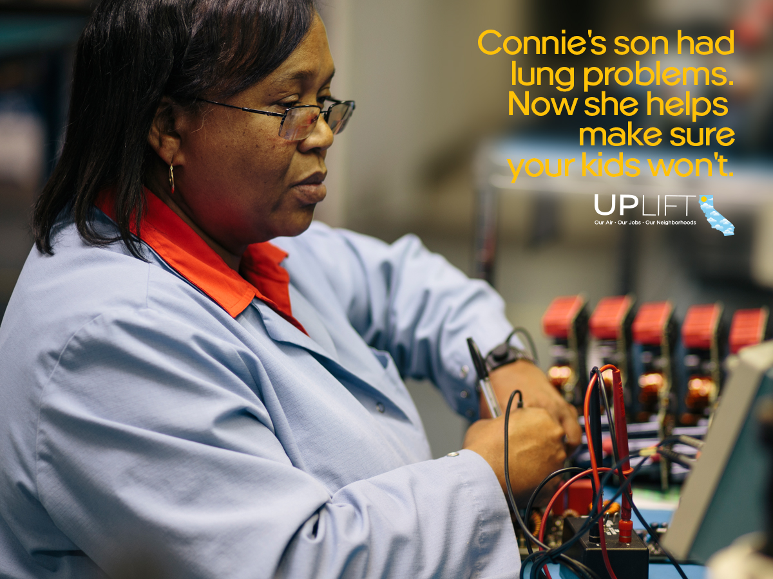
(right click, save as picture, and attach to posts below)

Facebook/LinkedIn:

Connie once dreamed of going into medicine. Today, she’s helping people lead healthy lives through a different way, by getting rid of air pollution, one clean vehicle at a time. Read her story: http://bit.ly/UpLiftConnie

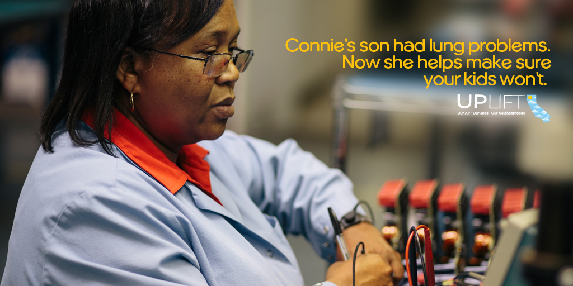
(right click, save as picture, and attach to posts below)

Twitter:

Connie dreamt of going into medicine. Now, she helps people get healthy another way: http://bit.ly/UpLiftConnie #UpLiftCA

CA #climatechange policy is helping people like Connie fight #airpollution: http://bit.ly/UpLiftConnie #UpLiftCA

Connie knows that health is linked to #environment. Read her story: http://bit.ly/UpLiftConnie #UpLiftCA

“LEE TIDWELL’S STORY”

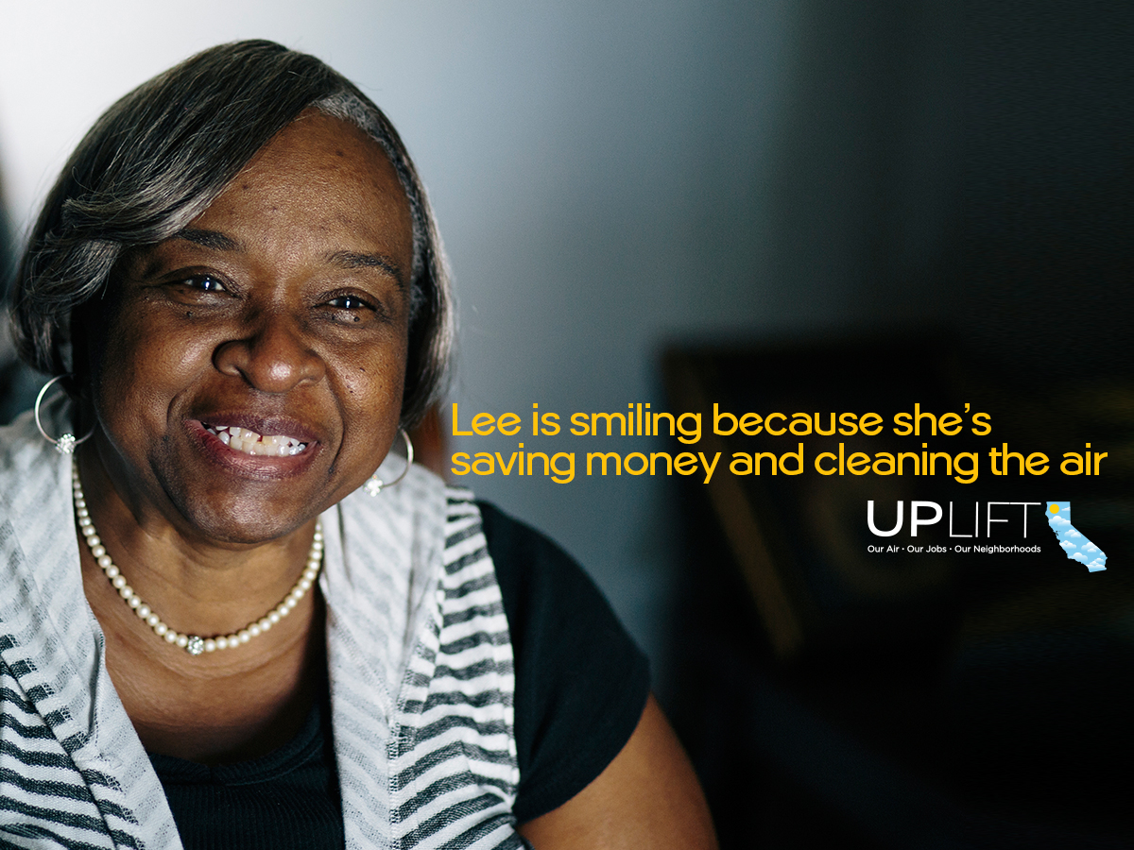
(right click, save as picture, and attach to posts below)

Facebook/LinkedIn:

Nobody wants to pay a $190 bill for electricity. Lee Tidwell hit the jackpot when she was able to get a rebate for energy efficiency upgrades in her home, ultimately helping her save money and the environment. Learn how she did it: http://bit.ly/UpLiftLee

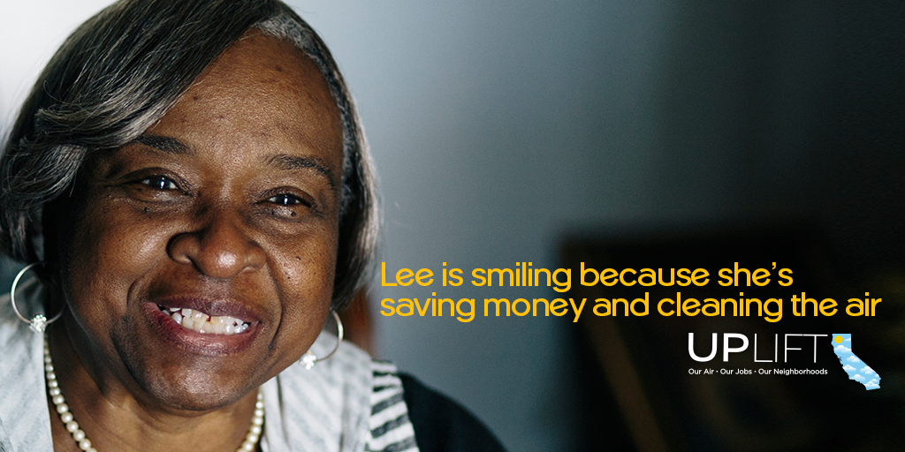
(right click, save as picture, and attach to posts below)

Twitter:

Lee Tidwell hit the jackpot w/ a rebate for #energyefficiency upgrades in her home: http://bit.ly/UpLiftLee #UpLiftCA

Hot LA summers & electricity bills don't go well together. See how Lee is saving $: http://bit.ly/UpLiftLee #UpLiftCA

“ALEX GHEBREHIWAT’S STORY”

(right click, save as picture, and attach to posts below)

Facebook/LinkedIn:

California’s climate change policies are helping taxi drivers like Alex switch from gas-guzzlers to cleaner alternatives of the future, creating savings and new jobs as a result. Read his story: http://bit.ly/UpLiftAlex

(right click, save as picture, and attach to posts below)

Twitter:

Thanks to CA #climatechange policies, Alex traded in his gas-guzzler for a Prius: http://bit.ly/UpLiftAlex #UpLiftCA

Thanks to CA #climatechange policies, Alex is saving $12k/yr as a taxi driver: http://bit.ly/UpLiftAlex #UpLiftCA

Save money on gas, while keeping the air clean? Alex has a win-win situation: http://bit.ly/UpLiftAlex #UpLiftCA

“DAVID DA LA PENA’S STORY”

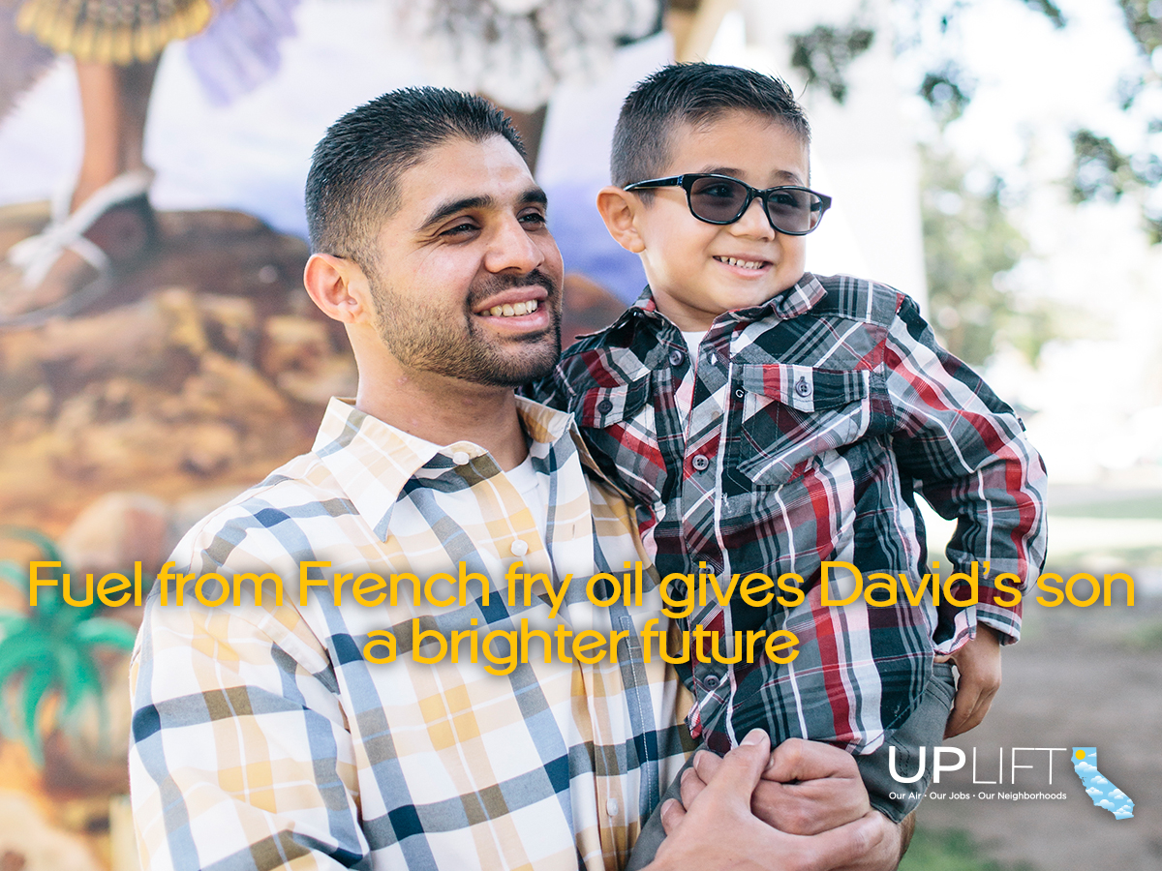
(right click, save as picture, and attach to posts below)

Facebook/LinkedIn:

Fact: biodiesel fuel recycled from waste grease reduces greenhouse gas emissions by 82 to 88 percent compared to petroleum diesel. David’s creating cleaner fuels all while supporting his son as a single father: http://bit.ly/UpLiftDavid

With his construction job in jeopardy after the Great Recession, David found a new opportunity in the alternative fuel sector, allowing him to support his son, little David: http://bit.ly/UpLiftDavid

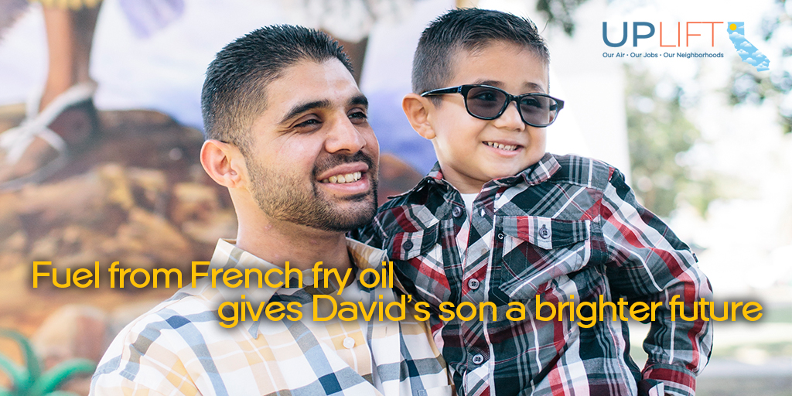
(right click, save as picture, and attach to posts below)

Twitter:

Fuel from French fry oil? Learn how David is creating cleaner fuels: http://bit.ly/UpLiftDavid #UpLiftCA

Turning grease into clean fuel allows David to support his family: http://bit.ly/UpLiftDavid #UpLiftCA

“DAVID DA LA PENA’S STORY, PT. II”

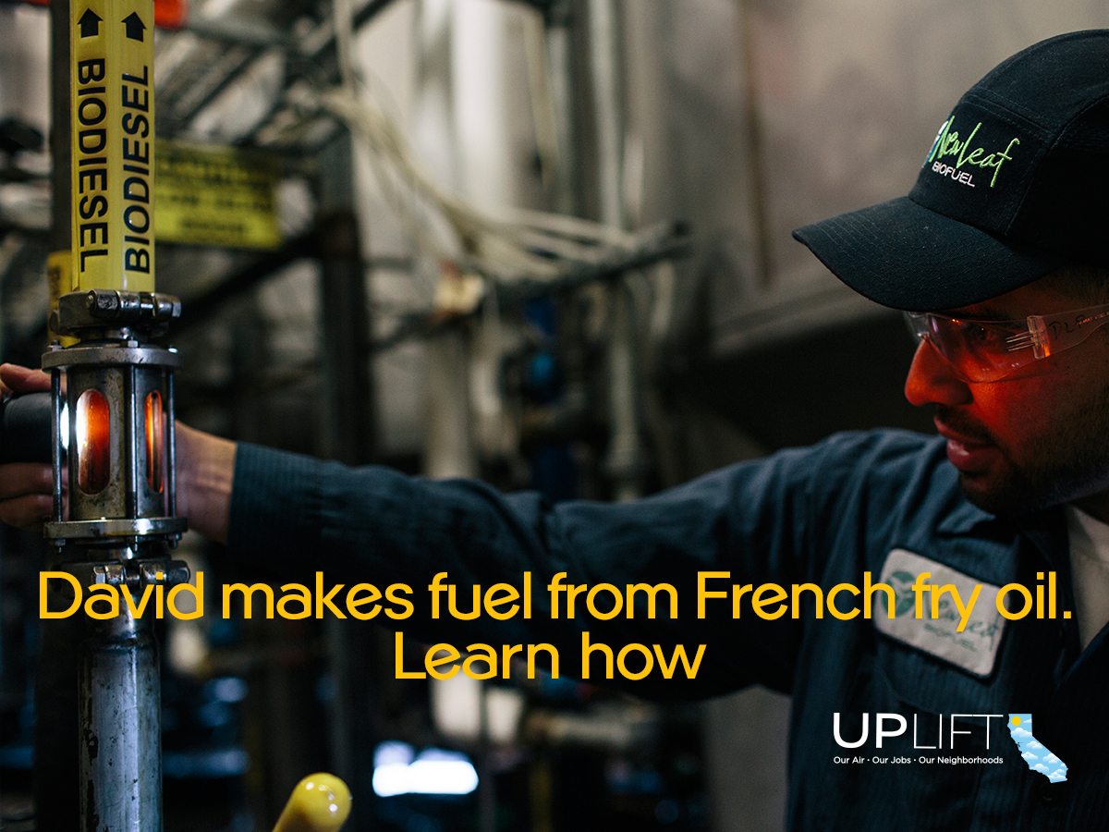
(right click, save as picture, and attach to posts below)

Facebook/LinkedIn:

Fact: biodiesel fuel recycled from waste grease reduces greenhouse gas emissions by 82 to 88 percent compared to petroleum diesel. David’s creating cleaner fuels all while supporting his son as a single father: http://bit.ly/UpLiftDavid

With his construction job in jeopardy after the Great Recession, David found a new opportunity in the alternative fuel sector, allowing him to support his son, little David: http://bit.ly/UpLiftDavid

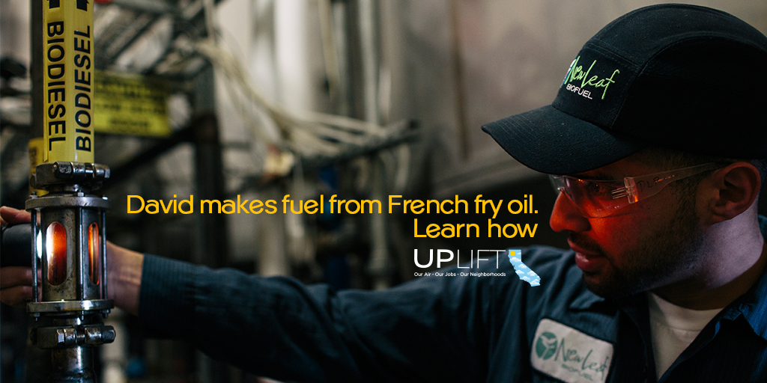
(right click, save as picture, and attach to posts below)

Twitter:

Fuel from French fry oil? Learn how David is creating cleaner fuels: http://bit.ly/UpLiftDavid #UpLiftCA

Turning grease into clean fuel allows David to support his family: http://bit.ly/UpLiftDavid #UpLiftCA

“MARIA ZAVALA’S STORY”

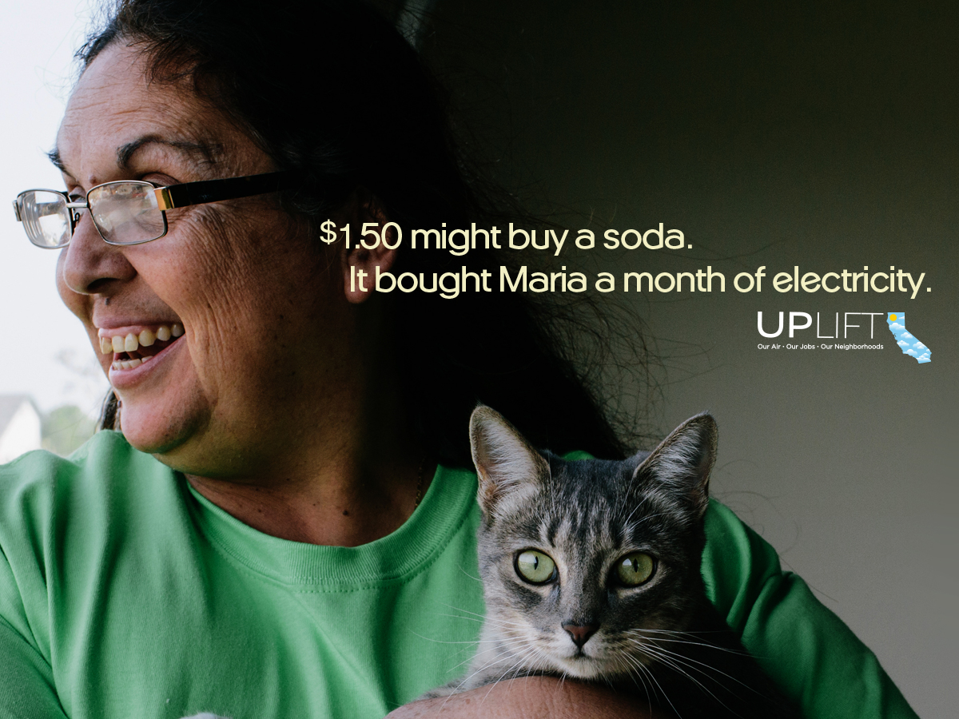
(right click, save as picture, and attach to posts below)

Facebook/LinkedIn:

Maria’s story shows some perspective on how California’s climate policies are helping families all across the state: http://bit.ly/UpLiftMaria #UpLiftCA

You think paying $1.50 for a month’s worth of electricity is a dream? California is making it possible: http://bit.ly/UpLiftMaria #UpLiftCA

We’d take a month’s worth of electricity over soda any day: http://bit.ly/UpLiftMaria #UpLiftCA

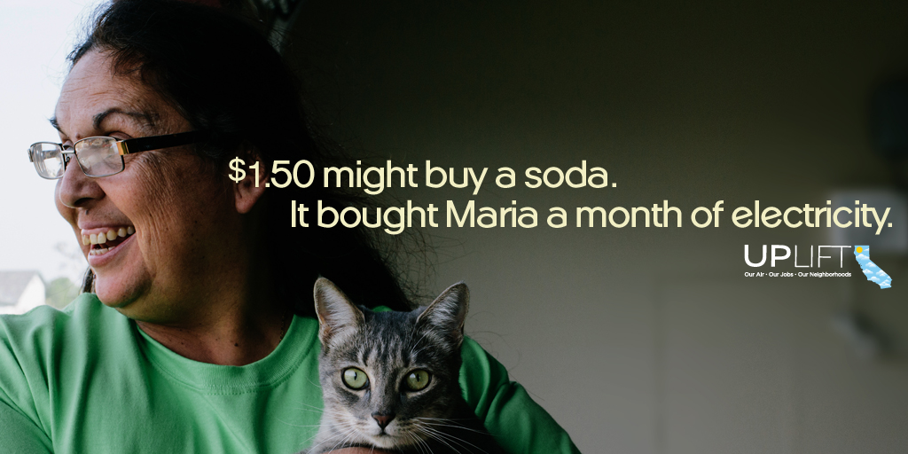
(right click, save as picture, and attach to posts below)
Twitter:

If you don't think $1.50 can go a long way, check out what it gets Maria: http://bit.ly/UpLiftMaria #UpLiftCA

Thanks to California's #climatechange laws, we can have affordable & clean energy: http://bit.ly/UpLiftMaria #UpLiftCA

Think $1.50 for a month of electricity is a dream? California is making it happen: http://bit.ly/UpLiftMaria #UpLiftCA

CA's #climatechange laws are helping people like Maria all across the state: http://bit.ly/UpLiftMaria #UpLiftCA

“JESSE MAGALLANES’ STORY”

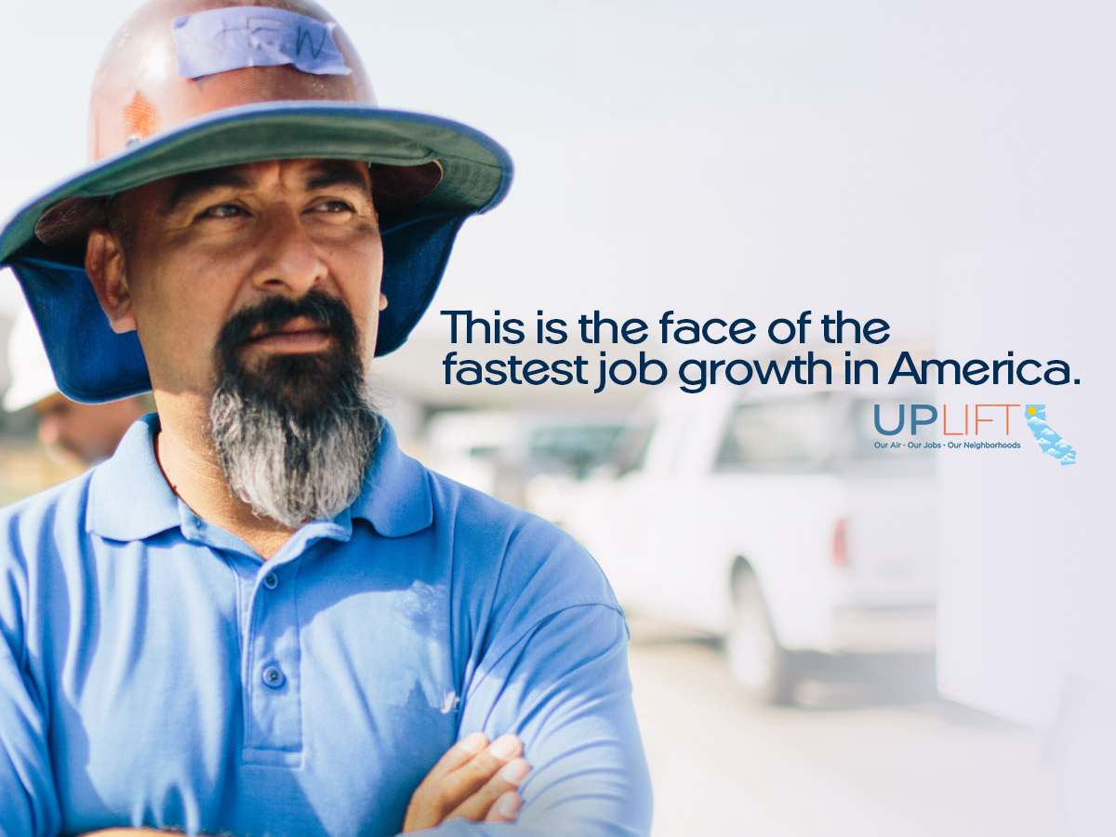
(right click, save as picture, and attach to posts below)

Facebook/LinkedIn:

California’s climate change policies are helping people like Jesse get good-paying jobs. Hit hard by the Great Recession, read his story about how he bounced back: http://bit.ly/UpLiftJesse

Clean energy + jobs = fastest growing sector in America. Read about how Jesse got his start as a solar installer: http://bit.ly/UpLiftJesse

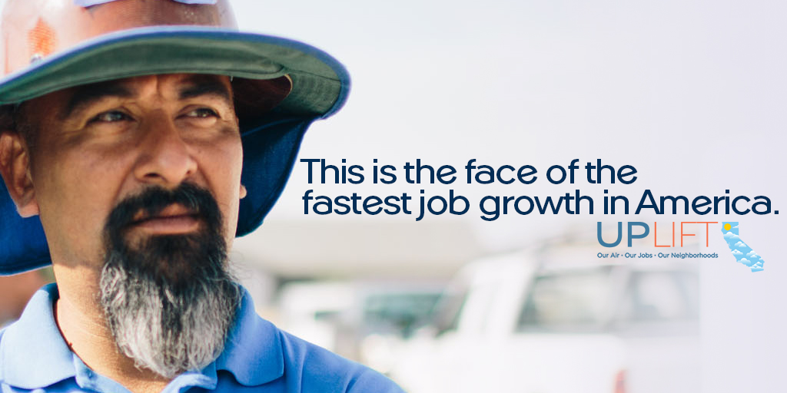
(right click, save as picture, and attach to posts below)

Twitter:

Clean energy = fastest growing job sector. It's helping people like Jesse: http://bit.ly/UpLiftJesse #UpLiftCA

Jesse was hit hard by the recession, now he has one of the fastest-growing jobs: http://bit.ly/UpLiftJesse #UpLiftCA

Jesse's story highlights the success of California's #climatechange laws. Read more: http://bit.ly/UpLiftJesse #UpLiftCA

A job that pays well and has a positive impact? That's what Jesse has: http://bit.ly/UpLiftJesse #UpLiftCA

This is what happens when we draw on the sun as an energy resource: http://bit.ly/UpLiftJesse #UpLiftCA

This is what the sun can do, and why a #cleanenergy economy works: http://bit.ly/UpLiftJesse #UpLiftCA

Why does a #cleanenergy economy work? It’s all in the numbers: http://bit.ly/UpLiftJesse #UpLiftCA

“DENNY SYSAKNOI’S STORY”

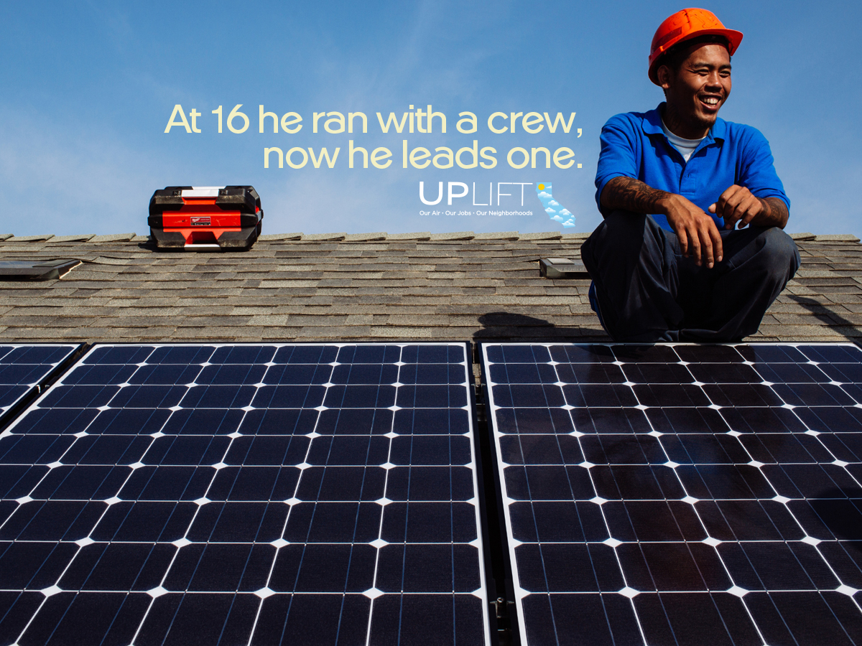
(right click, save as picture, and attach to posts below)

Facebook/LinkedIn:

California's climate change laws are not only protecting our environment, they're changing lives. Once headed for trouble, Denny Sysaknoi is now building a new life as a solar installer. Read his story: http://bit.ly/UpLiftDenny

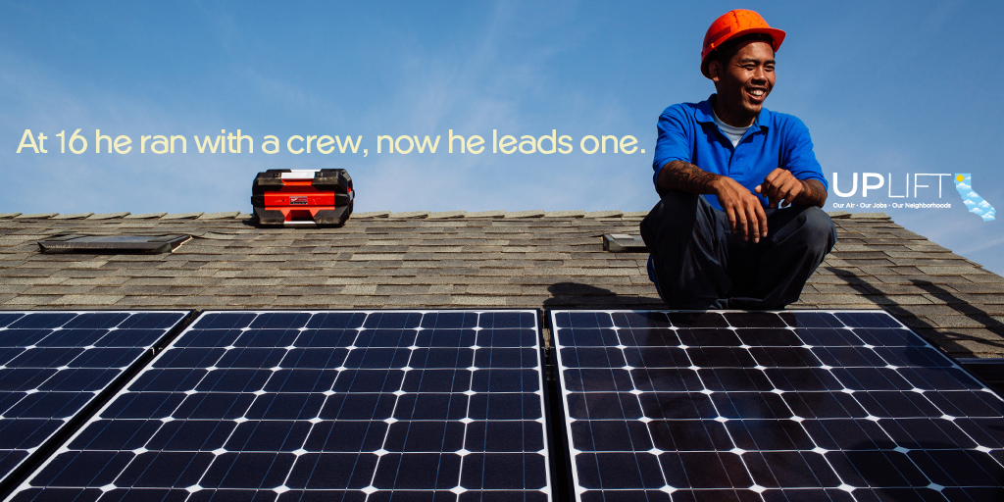
(right click, save as picture, and attach to posts below)

Twitter:

Once headed for trouble, Denny turned his life around as a #solar installer: http://bit.ly/UpLiftDenny #UpLiftCA

CA #climatechange policies are cleaning our environment & turning lives around: http://bit.ly/UpLiftDenny #UpLiftCA

“SOMETHING AMAZING IS HAPPENING IN CALIFORNIA”

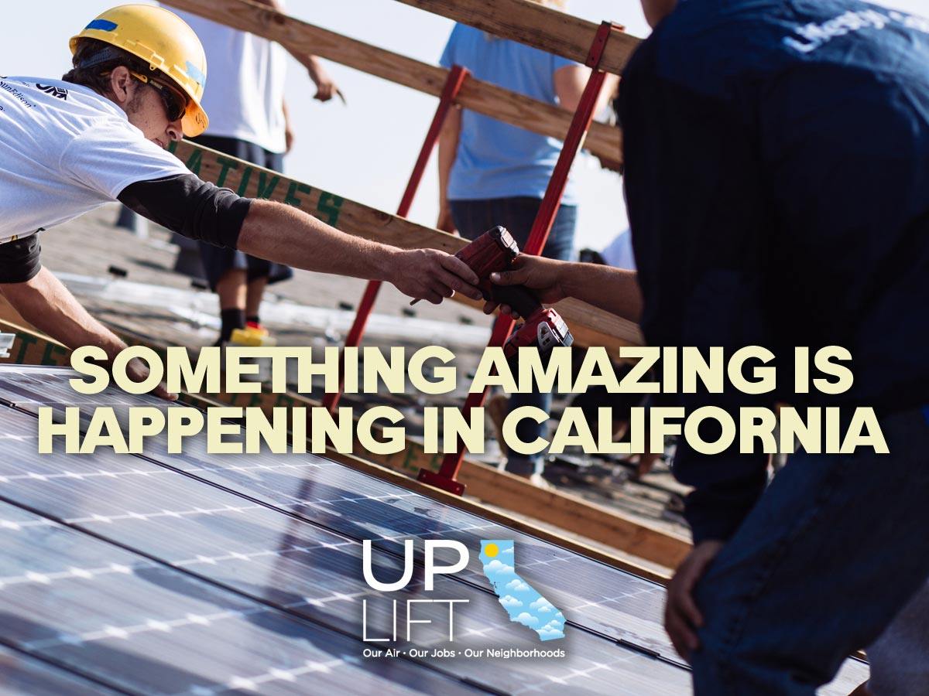
(right click, save as picture, and attach photo to posts below)

Facebook/LinkedIn:

California’s climate change laws are bringing economic opportunities to low-income communities and communities of color! Learn more here: http://bit.ly/UpLiftCA #UpLiftCA

Clean air and prosperous neighborhoods – we can have both! California is making it possible. Learn more here: http://bit.ly/UpLiftCA #UpLiftCA

Something amazing is happening in California that’s cleaning our air, creating good jobs, and building prosperous neighborhoods. Learn more: www.upliftca.org #UpLiftCA

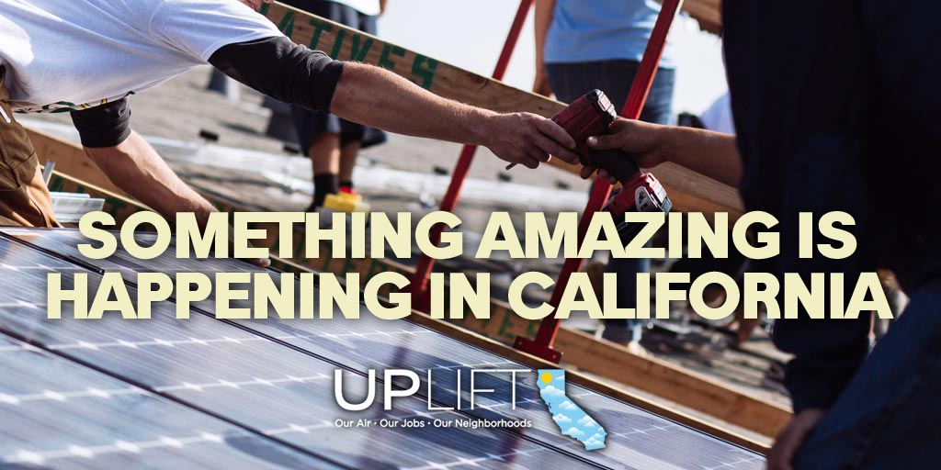
(right click, save as picture, and attach to posts below)

Twitter:

Clean air & prosperous neighborhoods. That’s what CA’s #climatechange laws are creating. Learn more: http://bit.ly/UpLiftCA #UpLiftCA

Clean air & good jobs. That’s what CA’s #climatechange laws are creating. Learn more: http://bit.ly/UpLiftCA #UpLiftCA

California is changing the game on #climatechange. Hear about what's happening: http://bit.ly/UpLiftCA #UpLiftCA

#UpLiftCA is telling the story of California’s impactful climate policies. Visit the site: http://bit.ly/UpLiftCA

The truth about California’s #climatechange policies? They’re working. See for yourself: http://bit.ly/UpLiftCA #UpLiftCA

$270 million going towards investments in polluted communities. Time to #UpLiftCA: http://bit.ly/UpLiftCA

Something amazing is happening in CA that’s cleaning our air & creating good jobs. Learn more: http://bit.ly/UpLiftCA

“I CAN SEE THE FUTURE FROM HERE”

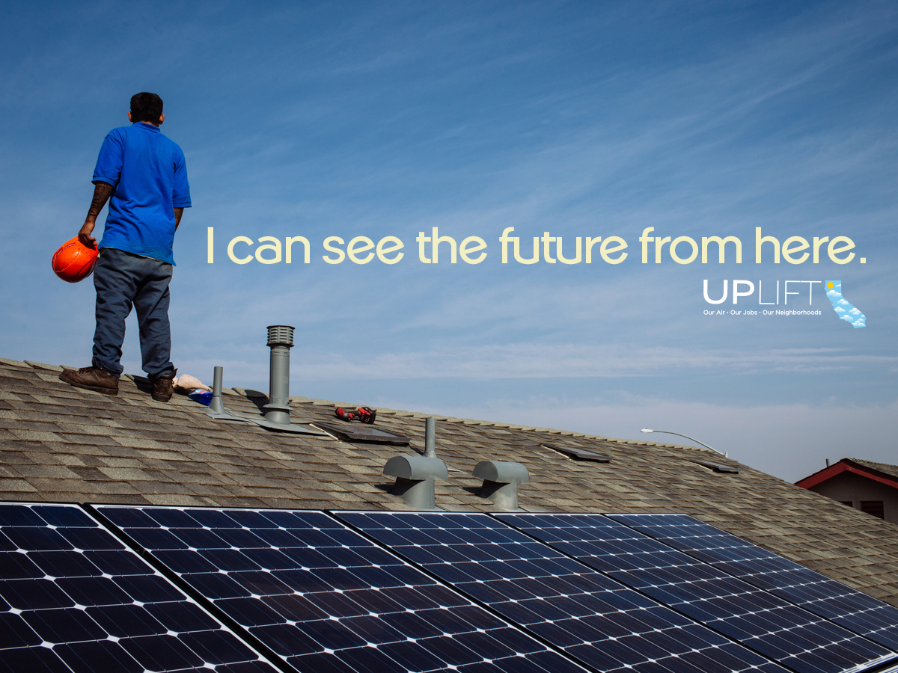
(right click, save as picture, and attach to posts below)

Facebook/LinkedIn:

Thanks to California’s climate change laws, our future is brighter, greener, and more sustainable. Learn how California is doing it: http://bit.ly/UpLiftCA #UpLiftCA

Imagine this: your home is its own power plant – bringing you affordable and sustainable energy. California is making that a reality: http://bit.ly/UpLiftCA #UpLiftCA

California’s clean energy future includes homes that power themselves. California’s climate change laws are making that happen: http://bit.ly/UpLiftCA #UpLiftCA

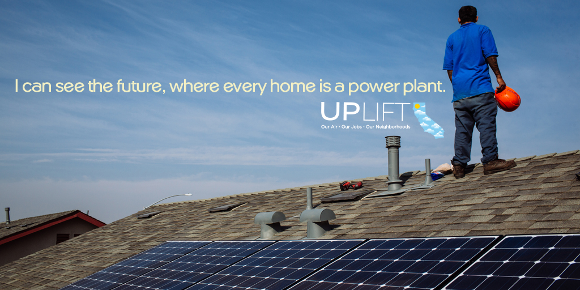
(right click, save as picture, and attach to posts below)

Twitter:

Imagine a world where your home provides its own electricity. It's happening in #CA: http://bit.ly/UpLiftCA #UpLiftCA

Thanks to California's #climatechange laws, the future is happening right now. http://bit.ly/UpLiftCA #UpLiftCA

California's #climatechange laws are leading us into the future, w/ #cleanenergy. http://bit.ly/UpLiftCA #UpLiftCA

The future is looking mighty clean and green in #California. Learn more here: http://bit.ly/UpLiftCA #UpLiftCA

SAMPLE EMAIL LANGUAGE

Subject Line: Something amazing is happening in California – be a part of it!

Dear _______,

Something amazing is happening in California: We’re charging polluters for the damage they cause and using that money to clean the air, save families money, and bring investments and jobs to communities that need them. But too few Californians know this is happening, or the good it’s doing for our neighborhoods. UpLiftCA will change that.

UpLiftCA is a comprehensive campaign launched by The Greenlining Institute to educate our communities about California’s climate and clean energy laws and how the fight against global warming helps consumers, generates jobs, and helps build healthy, thriving neighborhoods.

At UpLiftCA.org you can find stories of real California families whose lives have been changed for the better by our state’s climate policies, information about how these laws work, and a comprehensive collection of resources for families and small business owners.

To make this campaign successful, we need your help to spread the word! We’ve created an outreach toolkit with pre-made messages for various social media channels that you can use to promote the website to your networks. Thank you for your partnership and support!

